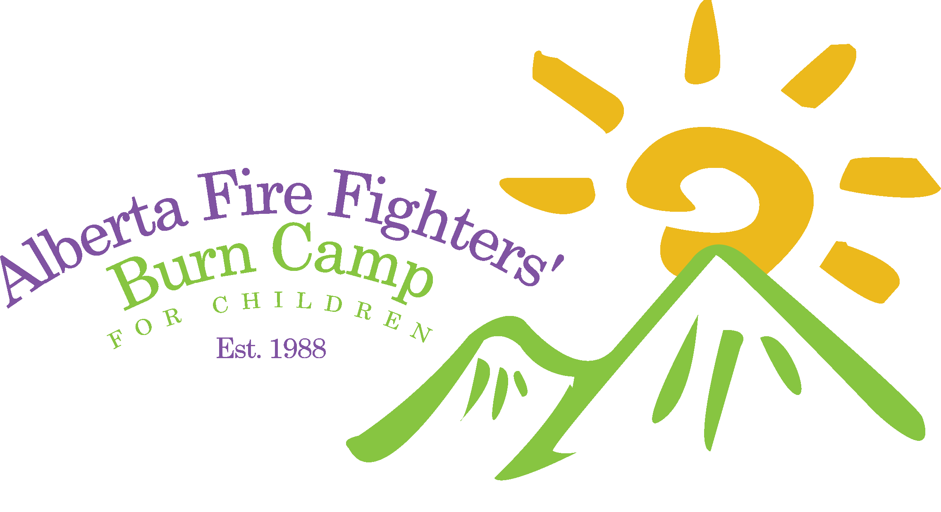
2019
Alberta Firefighters
Burn Camp Golf Tournament
8th Annual
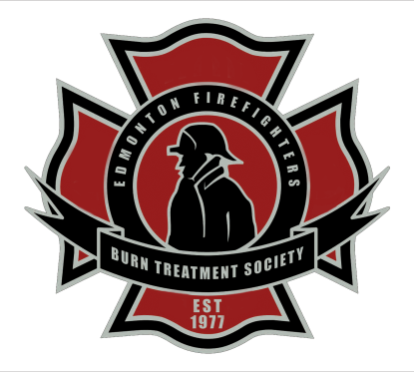
Sponsorship Package
Hosted by the Strathcona County Firefighters
The 2019 Alberta Firefighters Burn Camp Golf Tournament is once again being hosted by The Firefighters Burn Treatment Society, in partnership with the Strathcona Firefighters. This is our 8th Annual tournament benefiting Burn Camp, the date of this years event will be September 12, 2019 @ 12:30pm at the Broadmoor Golf Course in Sherwood Park AB.
Funds raised from the Golf Tournament support the Alberta Firefighters’ Burn Camp for Children. This year will be the 31st annual Burn Camp. We will be working hard to surpass our 2019 donation that totalled $19,000, which allowed 74 children to attend the camp last August. The purpose of this camp is to provide young burn survivors (Children aged 7-17 who have sustained a burn injury that required a skin graft or resulted in visible or psychological scarring) an opportunity to grow physically and emotionally while building self-esteem in a safe yet challenging environment. The Camp allows children from all over Western Canada to share their experiences with each other and build long-lasting & supportive relationships.
The annual camp is held at The Easter Seals Camp Horizons in Kananaskis. The cost of camp is approximately $1350 per child and is funded primarily by the Firefighters’ Burn Treatment Society. The only cost to the parents is a $50 administration fee that can also be subsidized by the Burn Treatment Society.
Thank you for considering being a sponsor for our 2019 Alberta Firefighters’ Burn Camp Golf Tournament.
If sponsorship is not for you at this time there are many other ways that you can help out the Burn Treatment Society and Alberta Firefighters’ Burn Camp by:
- Making a Monetary donation
- Donating a product or service to be used in a raffle or auction to raise funds
- Attend, Volunteer or Sponsor one of our other events

Sponsorship Packages
Gold Sponsorship $2000
- Corporate Advertisement on one golf course hole
- Corporate Advertisement on multiple golf carts
- Corporate Advertisement on a Gold Sponsorship Banner
- Four Entry fees paid for in the tournament including dinner (valued at $600)

Silver Sponsorship $1500
- Corporate Advertisement on one golf course hole
- Corporate Advertisement on multiple golf carts
- Three Entry fees paid for in the tournament including dinner (valued at $450)

Bronze Sponsorship $1000
- Corporate Advertisement on golf carts
- Two Entry fees paid for in the tournament including dinner (valued at $300)
Hole Sponsorship: Product/Insurance Cost
Food, Beverage, Vehicle, Money, or Other Prize for Hole-in-One Opportunity
- Corporate Advertisement on Golf Carts & Program
*Sponsorship deadline August 30, 2019*
Yes, we would like to become a sponsor of the 2018 Alberta Firefighters Burn Camp Golf Tournament. (Please check level of sponsorship below):

  - Platinum Sponsorship - $4000+
  - Gold Sponsorship - $2000
  - Silver Sponsorship - $1500
  - Bronze Sponsorship - $1000
  - Hole Sponsorship: Food, Beverage, Car, or Other (Insurance/Product)

Sponsor Contact Information
Please fill in the following section and return to the contact below:
Company Name: __________________________________________________________
(As you wish to appear in any media)
Name: __________________________________________________________________
Title: ___________________________________________________________________
Address: ________________________________________________________________
City: ______________________________ Province: _____________________________
Postal Code: _______________________

Contact Person: __________________________________________________________
Telephone: ( ) ___________________
Fax: ( ) ___________________
E-mail: ___________________________
Please include a j.peg or higher version of your company Logo, please obtain permission for our use of your company markings.
Please make cheques payable to: Firefighters Burn Treatment Society
In the Memo section please add: AFFBC Golf Tournament
Please mail cheques to:
Firefighters Burn Treatment Society
C/O: Darren Akister
Firefighters Burn Treatment Society
Suite 1, 7024 101 Ave.
Edmonton, AB T6A 0H7

Cheque Enclosed
